**INPUTTING DATA IN OTHER WAYS**

Devices for the Hand

Input devices are designed to be used by the hands. Specialized devices like touch screens enable the user to interact with the system by using his or her fingertips. Unlike, keyboards and mice, many of these input devices are highly intuitive and easy to use without special skills or training.

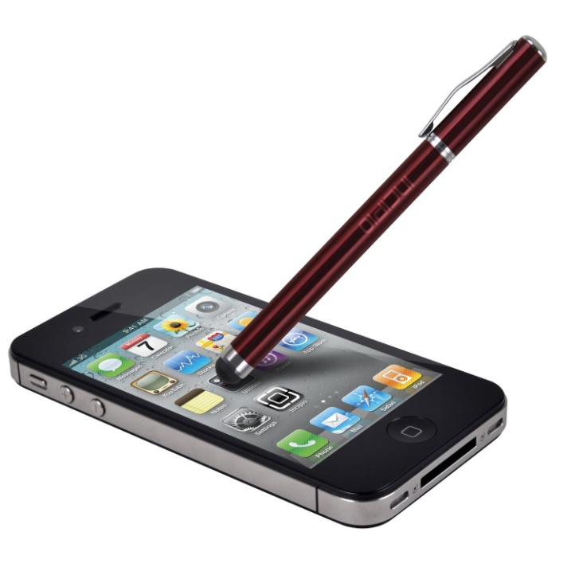**PENS**

Pen-based systems-including many tablet Pcs, PDA and other handheld computers- use a pen for data input. It is called stylus. This stylus can use as a pointing device, like a mouse, to select commands by tapping. Pen-based computers are not used generally to enter large amounts of text.

Pen-based computers are commonly used for data collection. Another common use is for inputting signatures or messages that are stored and transmitted as a graphic image, such as fax.

**TOUCHSCREENS**

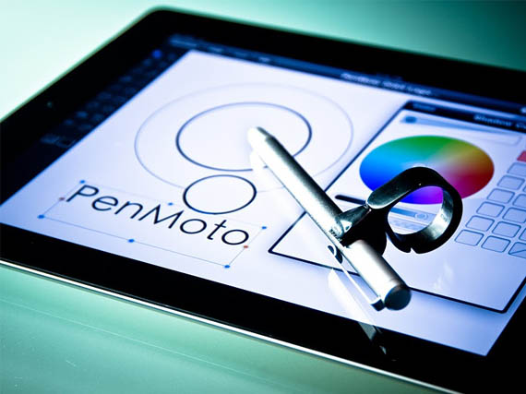

Touch screens accept input by allowing the user to place a fingertip directly on the computer screen, usually to make a selection from menu of choices.

Touch screens work well in environments where the dirt or weather would render keyboards and pointing devices are useless. They are well suited for simple application.

**GAME CONTROLLERS**

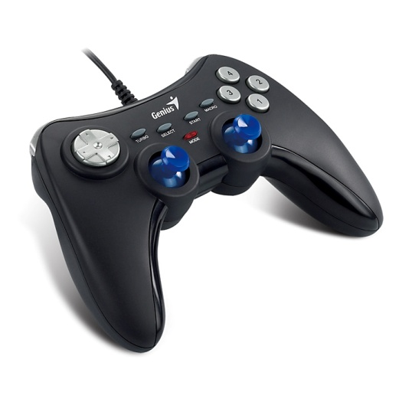

A game controller can be considered as an input device because a computer game is a program. A game accepts input from the user, process data, and products output in the form of graphics and sound.

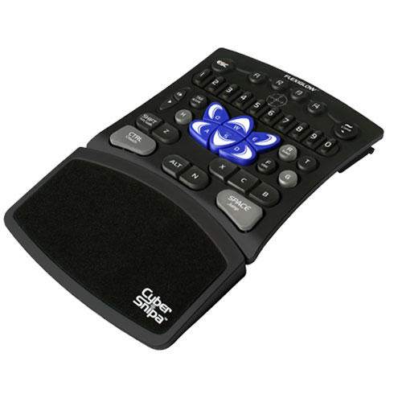Game controllers have two categories: Game pads and joysticks: Joysticks enable the user to “fly” or “drive” through a game, directing a particular vehicle or character.

.

Game pad is a small, flat device that usually provides two sets of controls-one for each hand. These devices are extremely flexible and are used to control many kinds of games.

Optical Input Devices

**BAR CODE READERS**

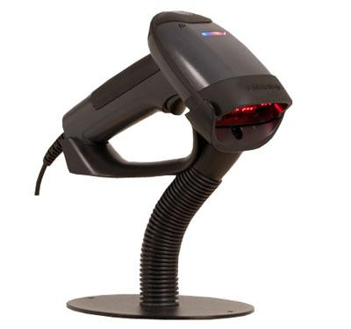

The most common type of a barcode reader is the flatbed model, which is commonly found in supermarkets and department stores.

Flatbed scanners offer high quality reproduction than do handheld scanners. To use a flatbed scanner, you place a page on the glass similar to a photocopier.

These devices read bar codes, which are patterns of printed bars that appear s on product packages. The bar codes identify the products. A light-sensitive detector identifies the bar code image by recognizing special bars at both ends of image These special bars are different.

After the detector has identified the bar code, it converts the individual bar patterns to a numeric digits-code the computer can understand.

IMAGE SCANNERS AND OPTICAL CHARATCER RECOGNITION

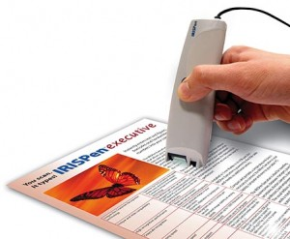

The bar code reader is a special type of image scanner. Image scanners (also called Scanners) convert any printed image into electronic form by shining light onto the image and sensing the intensity of light’s reflection.

Color canners use filters to separate the components of color into the primary additive colors.

The image scanner is useful because it translates printed images into an electronic format that can be stored into computers memory. You can use software or program to manipulate the electronic image. You might use optical character recognition (OCR) software or program to translate the scanned documents image into text that you can edit. When a scanner first creates an image from a page, the image is stored into the computer’s memory as a bitmap. The job of OCR software is to translate that array of dots into text that computer can interpret as letters and numbers.

To translate bitmaps into text, the OCR software looks t each character and tries to match the character with its own assumptions. OCR software is extremely complex and not always 100 percent reliable.

*SELF CHECK*

1. These are often used for taking notes, but not for entering large amounts for text.
2. Touch screens b. pen-based computer c. optical scanners

2. The racing game controller is a variation of this.

1. Joystick b. mouse c. scanner
2. A bar code reader emits this.
3. Sound b. light c. commands

*"SPEECH RECOGNITION”*

Science has explored the idea- talk to machines and does what they tell them. A popular sight at the 1939-1940 New York’s world fair was Westing house’s “elektro”, a 10 foot –tall “robot” that could walk, dance, speak and smoke a cigarette and it is obedient into spoken commands.

Computers can recognize human faces, machine parts and components with accuracy and precision. Computers do this by using very sophisticated software.

Voice recognition isn’t nearly as successful. Part of the problem resides in the nature of the sound. There are no obvious “lines” to separate the sound waves of your voice from the background noise.

*AUDIO VISUAL INPUT DEVICES*

**Microphone**

Sound capabilities are standard in computers; microphones are becoming increasingly important as input devices to record speech. Most PCs now have phone dialing capabilities. Having a microphone and speakers (or headset microphone with an earphone), can let you use your PC to make a call.

Microphones also make the PC useful for audio and video conferencing over the internet. This type of sound input, you need a microphone and a sound card. A sound card is a special device inside the computer, which translates analog audio signals (that is, sound waves) from the microphone into digital codes the computer can store and process. This process is called digitizing. Sound cards also can translate digital sounds back into analog signals that can be sent to the speakers.

Using simple audio recording software that is built into your computer’s operating system, you can use a microphone to record your voice and create files on disk. You can embed these files in documents, use them in Web pages, or e-mail them to other people.

Translating voice to text is a capability known as speech recognition (or voice recognition). With it you can dictate to the computer instead of typing, and you can control the computer with simple commands.

Speech recognition software takes the smallest individual sounds called phonemes, and translates them into text or commands. The challenge for speech-recognition software is to deduce a sound’s meaningful sound’s meaning correctly from its context and to distinguish meaningful sounds from background noise.

Speech recognition programs usually require the use of a noise cancelling microphone (a microphone that filters out background).

*Other Types of Audio Input*

Computers can accept many kinds of audio input, if your computer has a sound card with the appropriate plugs, you may be able to input music from a compact disc, a tape player, a radio or even a record player.

If the audio source outputs sounds in the form of analog waves, the computer’s soundcard must convert the analog signals into digital code so the computer can store and use it.

If your sound card has a built-in Musical Instrument Digital Interface (MIDI) port, or if you have a dedicated MIDI adapter, you can connect many kinds of electronic musical instruments to your computer.

**VIDEO INPUT**

The video cameras used with computers digitize images by breaking them into individual pixels. Each pixel’s color and other characteristics are stored as a digital code. This code can be compressed so that it can be stored on disk or transmitted over a network.

A popular and inexpensive type of PC video camera-called-Webcam-can sits on top of a PC monitor or be placed on a stand. Using a video capture card, the user also can connect other video devices such as VCRs and Camcorders to the PCs. This enables the user to transfer images from the video equipment to the PC and vice versa.

**DIGITAL CAMERAS**

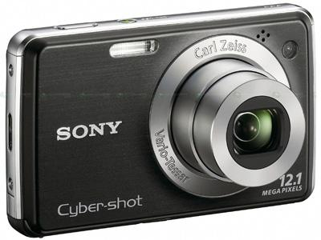

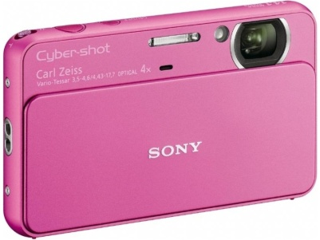

Digital cameras work much like PC video cameras, except that digital cameras are portable, handheld devices that capture still images. Normal film cameras capture images on a specially coated film, digital cameras images electronically. The digital camera digitizes the image, compresses and it stores it on a memory card. The image then can be copy, printed, embedded in a document or transmitted to another use.

Most digital cameras can store dozens of high –resolution images at a time, and most cameras accept additional memory that increases their capacity even further. Moving digital images from a digital camera to a computer is simple process that uses standard cables, disk, or even infrared and Bluetooth networking capabilities. Graphic designers can edit and enhance digital photographs using photo editing software.

*Key Term Quiz:*

Complete each statement by writing one of the terms listed under in each blank.

1. The pen used with a computer-such as a tablet PC-is also called a (n)
2. You might not think of a (n) ________________ as a true input device, but it is.
3. You can find ___________being used as input devices in supermarkets and department stores everywhere.
4. A bar code reader is a special type of ___________.
5. In a computer, a (n)__________ translates analog audio signals into digital codes that computer can use.
6. The process of translating voice into text or commands the computer can understand is called.
7. Using a special__________camera, you can participate in online videoconferences.
8. A (n) __________ is popular and inexpensive type of PC video camera.
9. Using a (n) __________, you can connect video devices such as VCR or camcorder to your PC.
10. Using a (n) _____________ stores till images on special memory card, rather than on film.

*Multiple Choices*

Circle the word or phrase that best completes each statement.

1. With a pen-based system, you can use the pen as a (n) _____________, to select commands.
2. Keyboard b. pointing device c. antenna d. microphone
3. Pen-based computers are commonly used for this type of work.
   1. Writing lots of text b. taking pictures . data collection d. recording sounds
4. __________ are well suited for use as input devices at automated teller machines or public information kiosks.
   1. Touch screens b. pens c. microphones d. monitors
5. A game controller can be considered an input device because a computer game is one of these.
   1. Joystick b. a part of a computer c. a fun past time d. a program
6. Game pads usually have two sets of these, one for each hand.
   1. Controls b. joysticks c. games d. microphones
7. This type of technology lets computers use light as a source input.
   1. Optative b. optical c. optimal d. optional
8. A (n) _____________ is used to identify a product and provide information about it, such as its price.
   1. Price check b. bar code c. numeric digit d. light-sensitive sensor
9. Which type of software can translate scanned text into text that you can edit?
   1. OCS b. ORC c. OCR d. ORS
10. The process of converting analog sounds into code a computer can use is called?
    1. Sound recognition b. optical character recognition c. scanning d. digitizing
11. This type of connection lets a computer communicate with, control, and record electronic musical instruments.
    1. DIMI b. MIDI c. DIIM d. MDII